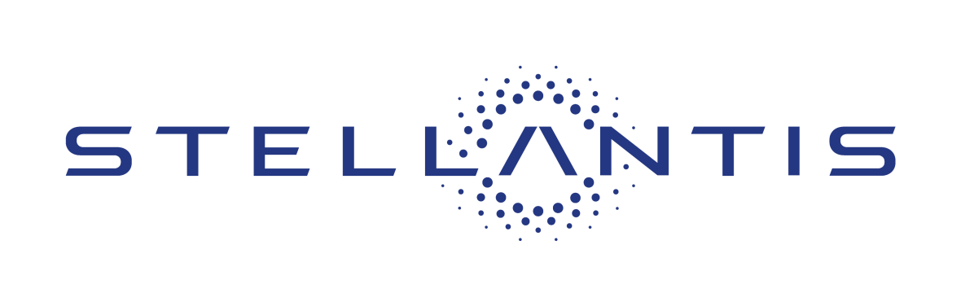

Stellantis Drive for Design Contest
presented by Stellantis Product Design Office
Drive for Design Guidelines
PROJECT BRIEF: Get ready for the future of cool vehicles with the Chrysler brand. Founded by the legendary Walter P. Chrysler, the Chrysler brand marks its 100th anniversary in 2025. From the Chrysler Pacifica minivan, the most awarded minivan ever to the sleek Halcyon concept vehicle, the brand has always been known for innovation, top-notch engineering, and stylish yet affordable rides. The future looks bright and we want to see what your vision of a future Chrysler brand vehicle would look like.
ELIGIBILITY: Entrants must be legal U.S. residents in grades 10-12 currently attending a U.S. high school
SUBMITTING ENTRIES: WWW.STELLANTISDRIVEFORDESIGN.COM
- Submit as a .pdf or .jpg, any medium accepted, size no larger than 11” X 17”
- Submit only one final design
- Interior or exterior design is acceptable
- Deadline for submission is midnight, Friday, April 25, 2025
- Entry must not contain material that violates or infringes upon another’s rights, including but not limited to, privacy, publicity or intellectual property rights, or that constitutes copyright infringement
- Submission must be the original work of the student entering the contest
TIMING AND DEADLINES:
- Monday, March 17, 2025 – Contest start date. Begin submissions.
- Friday, April 25, 2025 – Entries due via StellantisDriveForDesign.com
- Monday, May 12, 2025 – Winners announced

First Place Prize:
- Eligibility for a Summer Design Internship with the Ram Design Studio
- Apple iPad Pro and Apple Pencil
- Winning sketch to be featured on Stellantis social media platforms
- Local winners Invited to attend as a Student Judge for the prestigious EyesOn Design at Ford House car show in Grosse Pointe, Michigan on Father’s Day, June 15^{th,} 2025.

Second and Third Place Prizes:
- Apple iPad Pro and Apple Pencil
- Virtual networking opportunity with the Stellantis Design Team
- Sketches to be featured on Stellantis social media platforms
- Local winners invited to attend as a Student Judge for the prestigious EyesOn Design at Ford House car show in Grosse Pointe, Michigan on Father’s Day, June 15th 2025.
- Scholarship to College for Creative Studies three-week Precollege Summer Experience "Transportation Design" program. July 13 - August 2, 2025
Judging
- After an initial screening, submissions will be evaluated by a panel of qualified judges from the Stellantis North America Product Design Office
- Judges will evaluate each finalist’s entry according to the following weighted criteria:
  - Craftsmanship – 25%
  - Design Quality – 25%
  - Illustration – 25%
  - Originality – 25%
- The finalist with the highest overall score from the judges will be deemed the potential first place winner
- The finalists whose entries receive the next two highest scores from the judges will be deemed potential second and third place winners. (All winners are deemed potential winners pending verification of eligibility and compliance with these guidelines, as determined by Stellantis at its sole discretion)
- The decisions of Stellantis shall be final and binding in all matters pertaining to the Drive for Design contest

Students can follow all competition news on the Stellantis North America Facebook, X and Instagram channels using the hashtag #DriveForDesign.

Questions? Contact DriveForDesign@Stellantis.com
By submitting an entry, each Entrant agrees to be bound by these Official Rules and that his or her entry conforms to the entry guidelines and restrictions set forth in these Official Rules (“Entry Requirements”) and that Stellantis may, at its sole discretion, disqualify him or her from the Contest if Stellantis decides that his or her entry fails to conform to the Entry Requirements or any other provision of these Official Rules. Stellantis’ decisions regarding application and interpretation of these Official Rules shall be binding and final. Each entrant into the Contest (and his or her parent or legal guardian, if the entrant is under the age of majority in his or her state of residence [a “minor”]) hereby irrevocably grants, transfers, sells, assigns and conveys to Stellantis, its successors and assigns, all present and future right, title and interest of every kind and nature whatsoever, including, without limitation, all patents, design patents and copyrights, and all rights incidental, subsidiary, ancillary or allied thereto (including, without limitation, all derivative rights) in and to the entry for exploitation throughout the universe, in perpetuity, by means of any and all media and devices whether now known or hereafter devised. Stellantis shall have the right, in its sole discretion and without owing any additional consideration to entrant, to edit, composite, morph, scan, duplicate, alter, use or otherwise exploit each entry for any purpose which Stellantis deems necessary or desirable, and each entrant irrevocably waives any and all so-called moral rights they may have therein. Each entrant hereby acknowledges that such entrant does not reserve any rights in or to the entry. If Stellantis shall desire to secure additional assignments, certificates of engagement for the entry or other documents as Stellantis may reasonably require in order to effectuate the purposes and intents of these Official Rules, then each Entrant agrees to sign the same upon Sponsor’s request therefor. All [prizes will be subject to reporting to the internal revenue service.

